Contents

Admin login with valid details 2

Admin login with invalid details 3

Manage Trader 3

Manage Customer 4

Manage Shops 5

Manage Collections Slots 5

Access Trader Account 6

## Admin login with valid details

Expected Result: Admin is directed to admin dashboard

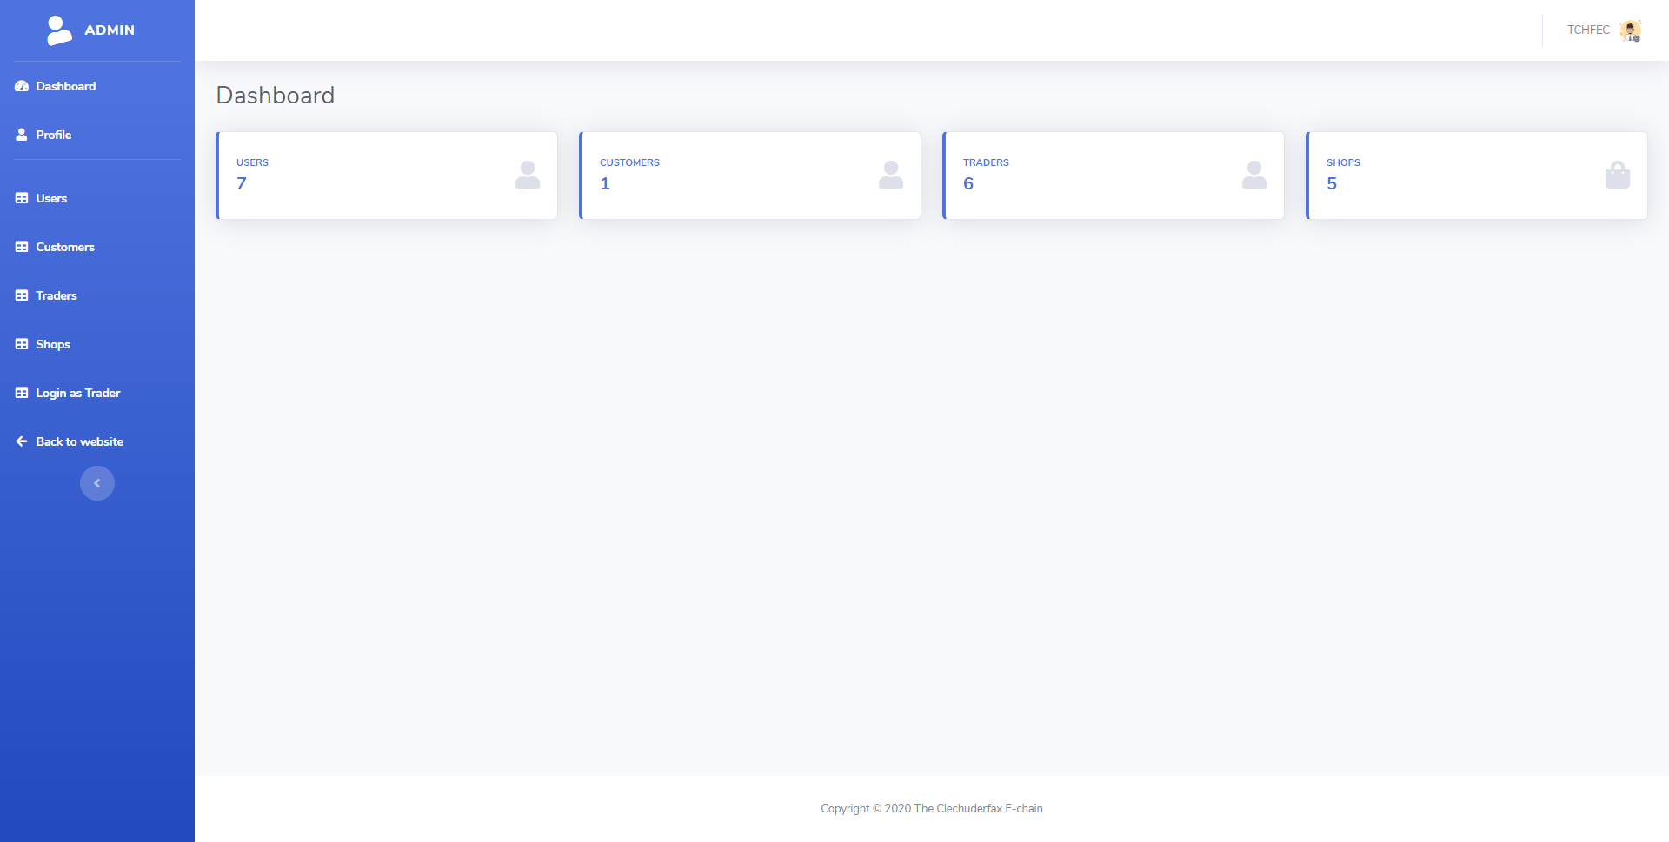

## Admin login with invalid details

Expected Result: Error message is displayed, and login is disallowed

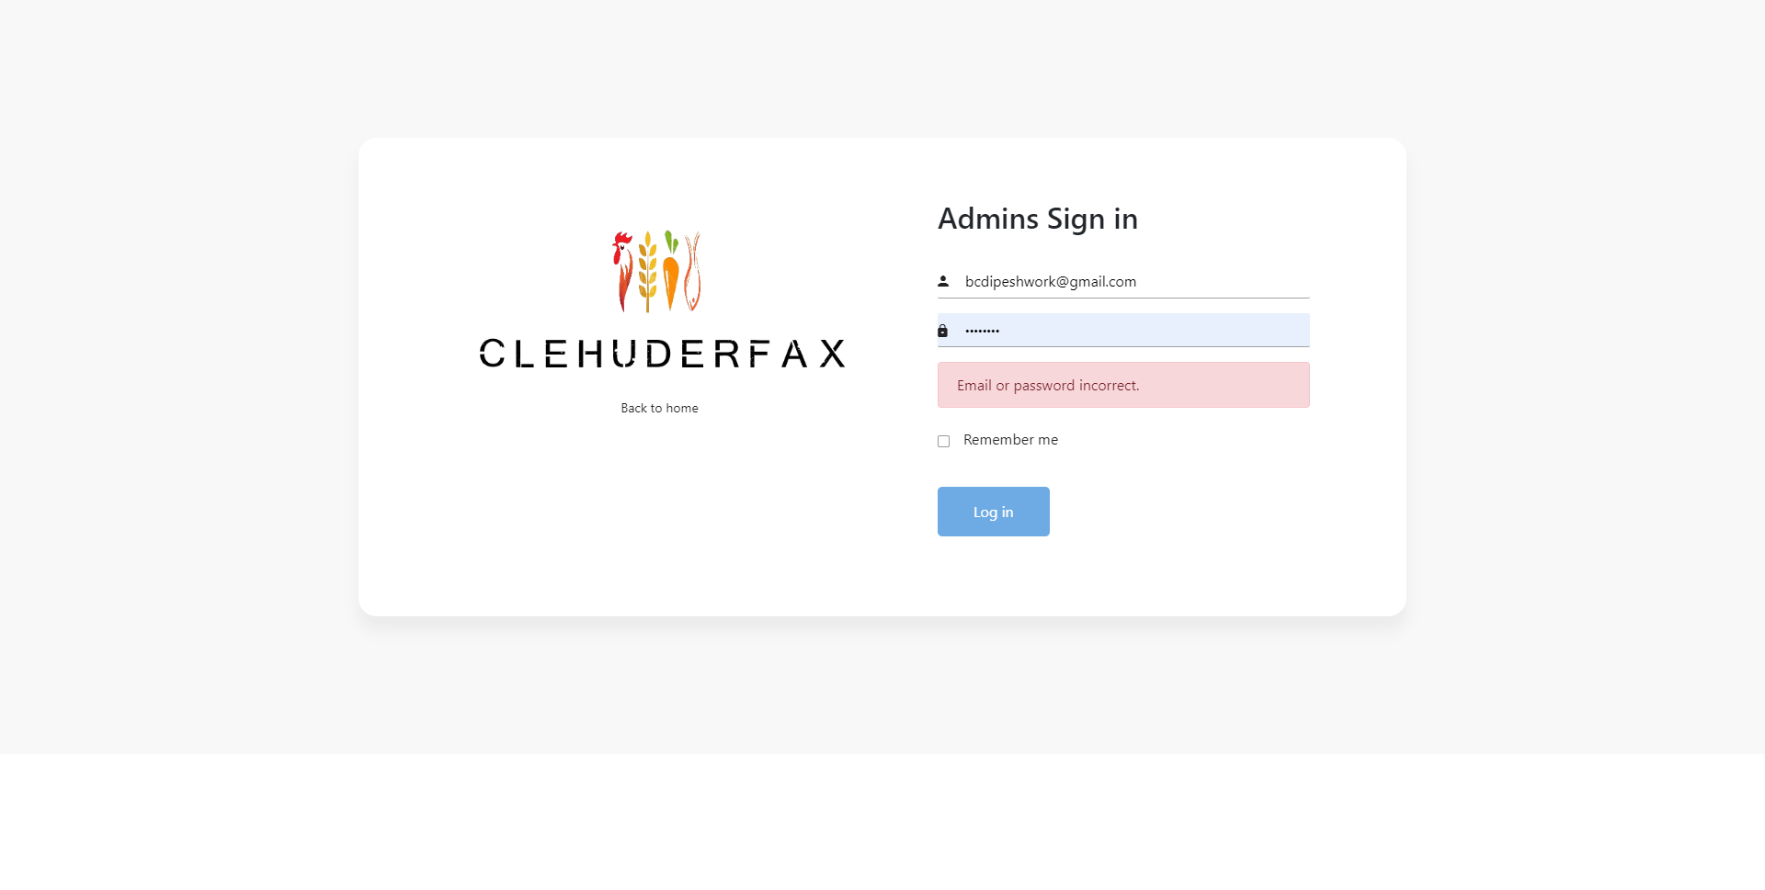

## Manage Trader

Expected Result: Update or delete traders options is shown with trader details.

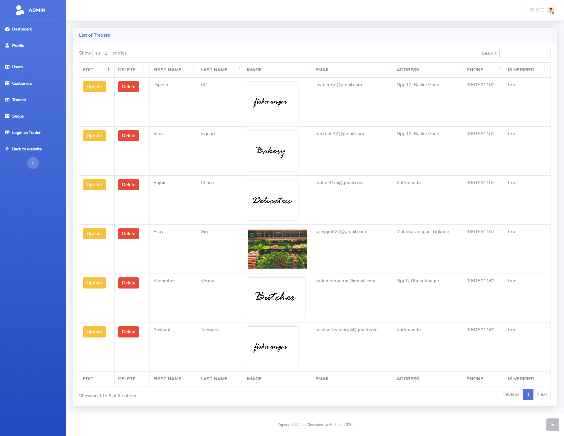

## Manage Customer

Expected Result: Update or delete customer options is shown with customer details.

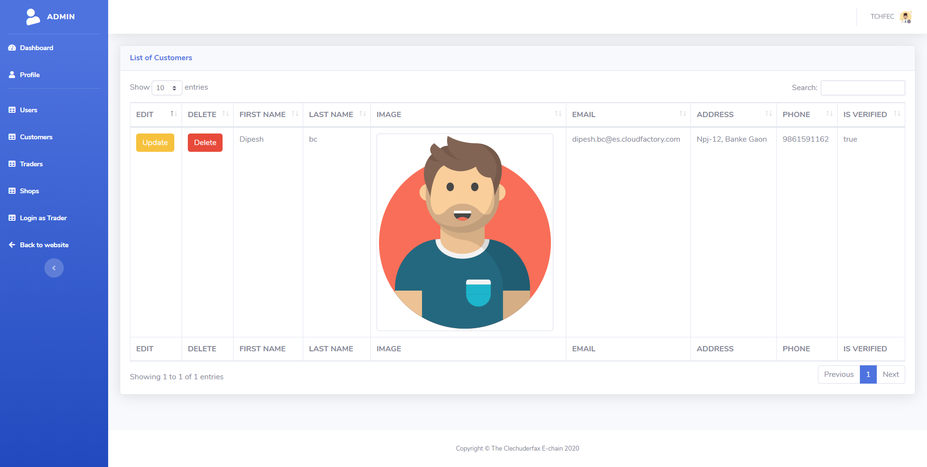

## Manage Shops

Expected Result: List of shops with update or delete option is displayed 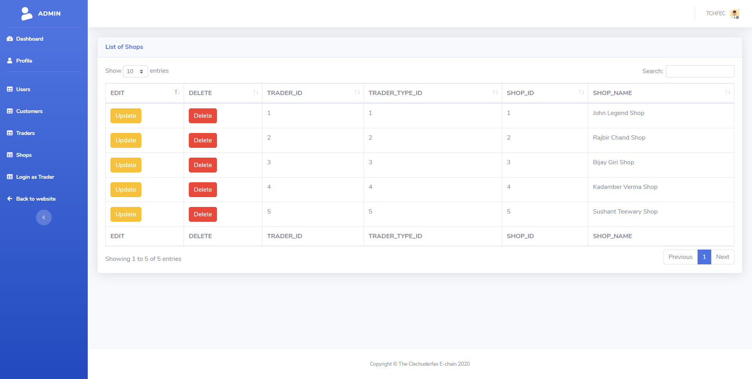

## Manage Collections Slots

Expected Result: 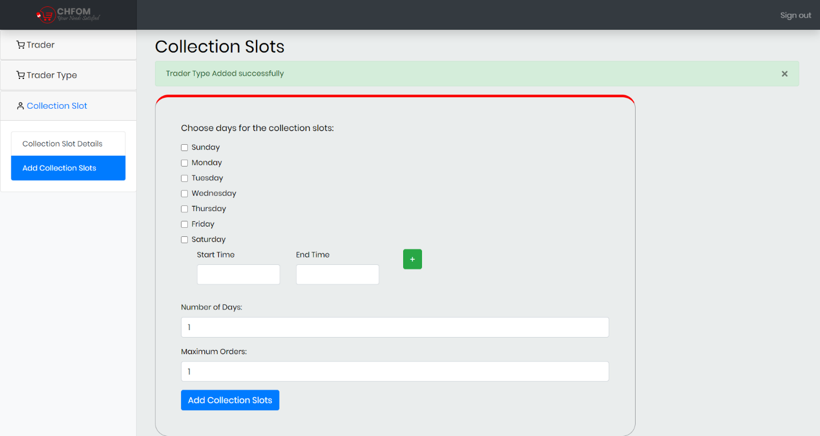

## Access Trader Account

Expected Result: Trader details with login button is displayed

